Exercice 2.1.1:
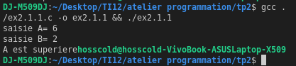

#include <stdio.h>
void main(){
int a,b;
printf("saisie A= ");
scanf("%d",&a);
printf("saisie B= ");
scanf("%d",&b);
if(a==b) {
printf("egale");
} else if (a < b){
printf("A est inferieur");
} else {
printf("A est superiere");
}
}

Exercice 2.1.2:
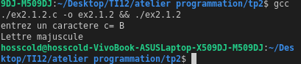

#include <stdio.h>
void main(){
char c;
printf("entrez un caractere c= ");
c=getchar();
switch (c)
{
case 65 ... 90:
printf("Lettre majuscule \n");
break;
case 97 ... 122:
printf("Lettre miniscule \n");
break;
case 48 ... 57:
printf("cest un chiffre \n");
break;
case 33 ... 47:
printf("cest un caractere special \n");
break;
default:
break;
}
}

Exercice 2.1.3:
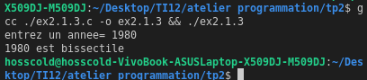
#include <stdio.h>
void main() {
int annee;
printf("entrez un annee= ");
scanf("%d", &annee);
if(((annee % 4 == 0) && (annee % 4 != 0)) || (annee % 400) ) {
printf("%d est bissectile \n",annee);
}
}

Exercice 2.2.1:

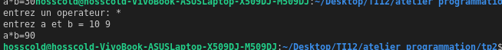
#include <stdio.h>
void main(){
int a,b;
char c;

printf("entrez un operateur: ");
scanf("%c",&c);
printf("entrez a et b = ");
scanf("%d %d",&a,&b);

switch (c)
{
case 43 :
printf("a=b=%d \n",a+b);
break;
case 45:
printf("a-b=%d \n",a-b);
break;
case 42:
printf("a*b=%d \n",a*b);
break;
case 47:
printf("a/b=%d \n",a/b);
break;
default:
break;
}
}

Exercice 2.2.2:
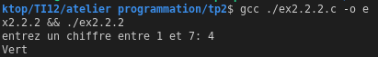

#include <stdio.h>
void main(){
int x;
printf("entrez un chiffre entre 1 et 7: ");
scanf("%d",&x);
switch (x)
{
case 1:
printf("Violet \n");
break;
case 2:
printf("Indigo \n");
break;
case 3:
printf("Bleu \n");
break;
case 4:
printf("Vert \n");
break;
case 5:
printf("Jaune \n");
break;
case 6:
printf("Orange \n");
break;
case 7:
printf("Rouge \n");
break;

default:
break;
}
}

Exercice 2.3.1:
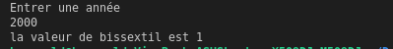
Donne 1 si lannee est bisextille sinon donne 0.

Exercice 2.3.2:
#include <stdio.h>
int main()
{
int mm,an;
int rs;
printf("Entrer une anneée \n");
scanf("%d",&an );
printf("Entrer un mois \n");
scanf("%d",&mm);

if (mm == 2)
{ rs = ((an % 4 == 0 && !(an % 100 == 0)) || (an % 400 == 0) ? 28 : 30); }
else if (mm <= 7)
{ rs = (mm % 2 == 1 ? 31 : 30); }
else
{ rs = (mm % 2 == 0 ? 31 : 30); }

printf("le dernier jour du mois est %d \n",rs);

return 0;
}

Exercice 2.3.3:
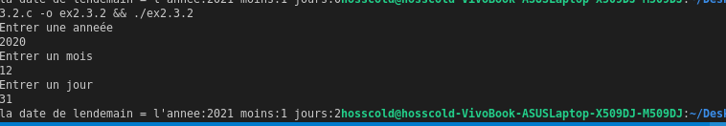
#include <stdio.h>

int main() {
int mm, an, jj;
int rs;
printf("Entrer une anneée \n");
scanf("%d", & an);
printf("Entrer un mois \n");
scanf("%d", & mm);
printf("Entrer un jour \n");
scanf("%d", & jj);

if (mm == 2) {
rs = ((an % 4 == 0 && !(an % 100 == 0)) || (an % 400 == 0) ? 28 : 30);
if (jj + 2 > rs) {
mm = mm + 1;
jj = (rs - jj) + 2;
} else {
jj = jj + 2;
}
} else if (mm <= 7) {
rs = (mm % 2 == 1 ? 31 : 30);
if (jj + 2 > rs) {
mm = mm + 1;
jj = rs % jj;
} else {
jj = jj + 2;
}
} else {
rs = (mm % 2 == 0 ? 31 : 30);
if (mm == 12) {
if (jj + 2 > rs) {
mm = 1;
an = an + 1;
jj = (rs - jj) + 2;
} else {
jj = jj + 2;
}
} else {
jj = jj + 2;
}
}

printf("la date de lendemain = l'annee:%d moins:%d jours:%d", an, mm, jj);

return 0;
}

